**EXERCISE HANDBOOK**

**TABLE OF CONTENTS**

EXERCISE OVERVIEW 3

* Purpose 3
* Incident vs. Accident 4
* Overall Objectives 4

EXERCISE STRUCTURE 5

* Exercise Outline 5
* Exercise Guidelines 7

COMMON USES FOR RADIOIACTIVE MATERIALS 7

* Medical and Research Applications 8
* Industrial Applications 8

RADIOLOGICAL TRANSPORTATION BACKGROUND 9

* Cause for Concern 9
* Safety of Shipments 10
* Container Standards 10
* Emergency Response 12
* Federal Roles and Responsibilities 12
* Department of Energy/National Nuclear Security Administration 12 (DOE/NNSA)
* Federal Bureau of Investigation (FBI) 13

APPENDIX A: TERMS AND DEFINITIONS 16

APPENDIX B: ACRONYMS AND ABBREVIATIONS 22

**EXERCISE OVERVIEW**

**PURPOSE**

**Isotope Crossroads: New Haven*,*** a Radiological Transportation Security Tabletop Exercise (TTX) is sponsored by The Department of Energy (DOE)/National Nuclear Security Administration (NNSA)/Office of Global Material Security (GMS) and the Federal Bureau of Investigation (FBI)/Weapons of Mass Destruction Directorate (WMDD)/Nuclear and Radiological Countermeasures Unit (NRCU).

The purpose of the TTX is to promote information sharing, joint situational awareness, team building, and problem resolution in a ***crisis response*** situation to Federal, State, and Local emergency response personnel, transportation companies, and radiological producing companies when dealing with a Weapons of Mass Destruction (WMD) incident scenario involving Category 1 and 2 radioactive or nuclear materials in commercial transit. Area of Responsibility (AOR) specific routes, transportation companies and response procedures, and radiological materials transported through the AOR will be discussed. The TTX is a one-day, no-fault, discussion-based exercise.

What to expect during the TTX:

* The TTX is designed to stimulate discussion about a wide variety of topics, including interagency communication procedures, coordination processes, responder actions, and radiological security measures as they apply to Federal, State, and Local law enforcement, and other response and support agencies.
* TTX participants include representatives from organizations that would be involved either in radioactive material transport and/or a response to an incident involving it. Delegates from all echelons of government, from Federal, State, and Local and key stakeholder agencies will be seated at the main table, but everyone present is encouraged to participate.
* This is a no-fault exercise environment; there will be no evaluation, no assessment, and no formal after-action report prepared by the facilitators following the TTX. Participants and observers are encouraged to apply lessons learned within their own organizations.
* Both the Exercise Handbook and the TTX itself are unclassified; all content is derived from open source materials. Some information presented during the exercise discussion may be considered sensitive and should be protected accordingly.

DISCLAIMER

Great care has been taken to develop a realistic and credible scenario. However, it does **not** represent any actual known threat or activity involving radiological transportation in/through the State. The scenario is intended to be a springboard for discussion; thus, some artificiality is needed to enable discussion of a wide range of issues in the time available.

**INCIDENT VS. ACCIDENT**

For the purposes of the **Isotope Crossroads** TTX, the FBI and DOE/NNSA define Incident and Accident as follows:

INCIDENT

An intentional act attempting damage, theft, unauthorized use or loss of control of a radioactive materials shipment involving suspected criminal or terrorist activity.

ACCIDENT

An unexpected or unintentional occurrence, including natural disasters, involving a radioactive material shipment that does not involve suspected criminal or terrorist activity.

**OVERALL OBJECTIVES**

1. Promote interagency communication and situational understanding in support of radiological/nuclear transport through the State.
2. Bolster the interoperability of multiple response agencies in the event of an incident towards or involving a radiological/nuclear shipment.
3. Discuss:
   1. Prevention and response
      1. Federal, State, and Local first responders
      2. Public Health Personnel
      3. Transportation companies
      4. Radioactive materials production companies
      5. Incident and unified command
      6. Media relations
      7. Turnover procedures
      8. Plume/casualty modeling and evacuation/shelter-in-place
      9. Tactical resolution
4. Crisis communications-related player requirements.

DOE/NNSA EXERCISE OBJECTIVES

1. Examine current carrier and local responder secure transport plans, policies, and procedures
2. Discuss carrier-specific integrated response plans with Federal, State, Local, and private-sector partners
3. Exercise coordination between multiple law enforcement agencies and responders tasked with responding to a terrorist threat/incident

FBI EXERCISE OBJECTIVES

1. Discuss:
2. FBI response mechanisms and procedures
3. Suspicious activity awareness
4. Awareness of routes/materials being shipped through the State
5. Joint Terrorism Task Force (JTTF)
6. National-level policy
7. National Response Framework (NRF)
   1. Nuclear/Radiological Incident Annex
   2. Terrorism Incident Law Enforcement and Investigation Annex
8. Site control/command and control turnover

NEW HAVEN EXERCISE OBJECTIVES

As they apply to the response to a radiological transportation security incident in Connecticut:

1. Discuss the security measures, both Federal- and State-level, regarding Category 1 and 2 radiological shipments across Connecticut.
2. Examine the communication and notification process between Federal, State, Local and private industry organizations during a transportation security incident.
3. Discuss the evolution of the command and control structure, particularly as it involves coordination with multiple agencies, and the development of a Unified Command.

**EXERCISE STRUCTURE**

**EXERCISE OUTLINE**

The TTX is divided into three phases: Orientation, Exercise Play, and Hot Wash.

ORIENTATION

* Orientation to the venue and schedule for the day
* Introduction of participating organizations and players
* An overview of exercise structure, reference materials and exercise injects.

EXERCISE PLAY – FOCUSED ON ***CRISIS RESPONSE***

* The TTX is comprised of scripted play and will focus on ***crisis response*** and Federal, State, and Local efforts to respond to an incident involving the transportation of radiological material through the State.
* Multiple agencies throughout the State are involved in crisis response efforts. Accordingly, command, control, and coordination among these assets will be a priority during the immediate and follow-on response efforts. The central role for Federal, State, and Local agencies in responding to an incident becomes protection of life and property, while law enforcement investigates the cause of the incident and attempts to bring the perpetrators to justice.
* Crisis communications and the dissemination of timely and accurate information to emergency responders, response organizations, and the public is critical during a rapidly evolving incident involving WMD materials. As such, crisis communication strategies will be included in the discussion as they apply to the scenario.
* Participants will be asked to determine:

1. who is in charge;
2. who will respond to an incident involving the transportation of radiological materials;
3. what level of response is warranted;
4. how to determine threat credibility; and
5. how to balance keeping the public informed while protecting sensitive information related to an incident and protecting evidence during an investigation.

* Discussion will include emergency managers’ actions to ensure responders have the most effective emergency response procedures available, given the situation.
* While there will be some elements of consequence management discussed, it is important to reiterate the TTX will focus on the crisis response portion, and efforts to prevent the scenario from becoming a full consequence management event.

HOT WASH

Immediately following the Exercise Play portion of the TTX, the facilitators will conduct a Hot Wash to gather immediate player feedback on the exercise. Useful feedback will include individual and agency takeaways from the TTX; recommended updates to agency policies and procedures; and suggested networking and planning opportunities for the agencies represented within the group.

After the TTX registered participants will be sent an email containing a link to the Participant TTX Critique. This critique is focused on improving the overall **Isotope Crossroads** exercise series and solicits comments on specific portions of the TTX that worked well, areas where it could be improved, and the overall value of the exercise to the participants. This is **not** a critique of player actions, but an opportunity to provide observations, comments and suggestions to improve the TTX series. Once the completed participant critique is submitted, a certificate of participation will be made available.

**EXERCISE GUIDELINES**

* **Use the scenario:** The scenario setting and incident details are designed to be used as a tool to stimulate discussion, not to portray weaknesses or vulnerabilities. The scenario timeline may be condensed or altered to provide the opportunity to maximize discussion topics.
* **Resist competition:** The TTX is not a zero-sum or win/lose game. Participants are not competing against the facilitators, nor are the facilitators leading the participants to a predetermined “right” or “wrong” solution.
* **Use time wisely:** As with any real-world incident, there is limited time for making decisions, and information will be incomplete and ambiguous.
* **Follow professional instincts:** Participants’ knowledge and experience will determine how each organization will respond to an incident (or potential incident) involving a radiological shipment transiting through the State. Each participant is encouraged to think outside of the box, use critical decision-making skills, and personal experience to challenge the status quo and develop innovative approaches in a dynamic, group environment.
* **Be realistic:** Only those resources an agency/organization has on hand at the time of the exercise will be allowed in exercise play.

**COMMON USES FOR RADIOACTIVE MATERIALS**

“Radioactive sources are used in every country in the world, whether in industry, medicine, agriculture, or research. At the same time, high-activity radioactive sources can be used for malicious acts.”

*Source: 2014 Nuclear Security Summit Communique*

Since radioactive materials, specifically cobalt-60, cesium-137 and iridium-192 are so commonly used in industrial, medical, and research applications across the nation, it is important to note that they are also transported to a wide variety of locations across the nation with significant frequency.

**MEDICAL AND RESEARCH APPLICATIONS**

Minimally invasive procedures involving radioactive material and radiation generating devices are used in medicine, specifically nuclear medicine and radiology, to allow physicians to explore bodily structures and functions in the living body. Radiation is used in medicine ([radiation](http://science.jrank.org/pages/5636/Radiation.html) oncology) to treat various cancers and other medical conditions.

Cobalt-60 is the source found in the Gamma Knife device commonly used to treat diseases such as brain tumors/lesions, arteriovenous malformations (AVM), and acoustic neuromas.

Iridium-192 is used as the source for brachytherapy often used to treat diseases such as prostate, head/neck, breast, and cervical cancers.

Cesium-137 is commonly used in blood irradiators to irradiate blood components prior to transfusion to help eliminate factors that can lead to graft-vs-host disease. It is also used in research irradiators for biomedical research.

*Sources:* [*https://www.cancer.gov/about-cancer/treatment/types/radiation-therapy*](https://www.cancer.gov/about-cancer/treatment/types/radiation-therapy)

*,* [*https://www.columbianeurosurgery.org/treatments/gamma-knife-radiosurgery/*](https://www.columbianeurosurgery.org/treatments/gamma-knife-radiosurgery/)*, and* [*http://www.aabb.org/advocacy/regulatorygovernment/irradiation/Pages/default.aspx*](http://www.aabb.org/advocacy/regulatorygovernment/irradiation/Pages/default.aspx)

**INDUSTRIAL APPLICATIONS**

Industrial Radiography works in much the same way as x-rays screen luggage at airports – the radiation penetrates the object leaving an image that can be studied. X-ray machines are often used for industrial applications. However, radioactive sources such as cobalt-60 and iridium-192 can also be used due to their emissions of gamma rays, which behave very similarly to x-rays.

Cobalt-60 is used in industrial radiography to inspect metal parts and welds for defects.

Iridium-192 is used principally for non-destructive testing (NDT) and, to a lesser extent, as a radiotracer in the oil industry. Industrial gamma radiography involves the testing

and grading of welds on pressurized piping, pressure vessels, high-capacity storage containers, pipelines, and certain structural welds.

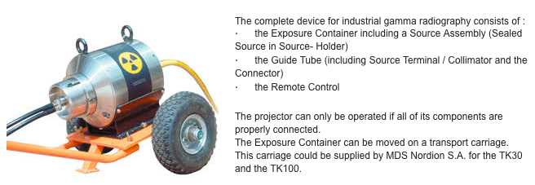

*Industrial gamma radiography device on towed carriage. Source Projector: TK-100*

Industrial irradiators are machines that expose products to very high levels of gamma radiation to kill germs and insects or for other purposes such as increasing the shelf life. Food, food containers, spices, fruits, plants and medical supplies are the products most commonly irradiated. The process does not leave radioactive residue or cause the products to become radioactive. The radiation can come from radioactive sealed sources, an x-ray tube or an electron beam.

Aside from its use in medicine, cesium-137 – one of the most common radioisotopes produced from fission – is also commonly used in industry. Among its uses are for density/thickness gauging, well logging, level switches, and for low-intensity gamma sterilization. It is also commonly used to calibrate instruments that measure radiation.

**RADIOLOGICAL TRANSPORTATION BACKGROUND**

**CAUSE FOR CONCERN**

The radioactive components for a Radiological Dispersal Device (RDD) are located at thousands of sites – such as hospitals and industrial facilities – around the world, many of them poorly secured and vulnerable to theft. The vulnerability of these radiological sources, such as cesium-137 and cobalt-60, has caused concern for years, but today the risk is growing. The probability of a terrorist detonating a RDD is much higher than that of an Improvised Nuclear Device (IND) because of the widespread availability of radiological sources.

*Source: March 2016 Nuclear Threat Initiative Radiological Security Progress Report*

Cesium-137 has a half-life of slightly over 30 years. Cesium-137 is associated with both beta and gamma radiation, but the gamma rays are typically of most concern. It is one of several known isotopes that stand out as being highly suitable for radiological terrorism. Cesium-137 mimics potassium in the body. It binds to concrete and other masonry, making decontamination of buildings extremely difficult and possible economic impacts. Use of Cesium-137 in an urban setting would seriously raise the cost of cleanup.

Cesium-137 is mostly used in the form of cesium chloride (CsCl). CsCl appears similar to table salt, but can also be processed into a fine, light powder with typical median particle size of about 300 microns. Fractions below 10 microns are typically less than 1%. In a Radiological Dispersal Device (RDD), most will fall out within approximately 1 to 2,000 feet (although many variables exist) but a small amount may be carried great distances – even hundreds of miles.

*Source: GlobalSecurity.org*

**SAFETY OF SHIPMENTS**

About 3 million packages of radiological materials are shipped each year in the United States, either by highway, rail, air, or water. Regulating the safety of these shipments is the joint responsibility of the Nuclear Regulatory Commission (NRC) and the Department of Transportation (DOT). The NRC establishes requirements for the design and manufacture of packages with radiological sources. The DOT regulates the shipments while they are in transit and sets standards for labeling and smaller quantity packages.

*Source: Nuclear Regulatory Commission (https://www.nrc.gov/materials/transportation.html)*

**CONTAINER STANDARDS**

Shippers transport materials with the highest levels of radioactivity in containers, or Type B packages, that are extraordinarily strong. The NRC requires that the shipping container maintain its integrity under both normal and accident conditions to provide first-rate protection. Type B packages must withstand variable environments including simulation of heat and cold, change in pressure, water spray (to simulate rain), vibration (to simulate travel conditions), puncture, and compression. During testing for accident-type conditions, containers must pass impact, puncture, fire, and water immersion tests. In addition, testing is sequential, “including a 30-foot drop onto a rigid surface followed by a fully-engulfing fire of 1,475 degrees Fahrenheit for 30 minutes.” According to the NRC, Type B packages meeting these standards would survive nearly all transportation accidents without releasing radioactive material. Safety records are consistent with this.

*Sources: Nuclear Regulatory Commission; World Nuclear Organization, and Nuclear Energy Institute; and Congressional Research Service Report for Congress: Transportation of Spent Nuclear Fuel*

The following photographs and illustrations are examples of various types of shipping containers used to transport radioactive material.

A Type B package may be a metal drum or a huge, massive shielded transport container. Type B packages must pass certain tests. Most Type B packages have been issued a Certificate of Compliance by the NRC.

*Sources: NRC For more information visit - http://www.nrc.gov/reading-rm/basic-ref/teachers/11.pdf*

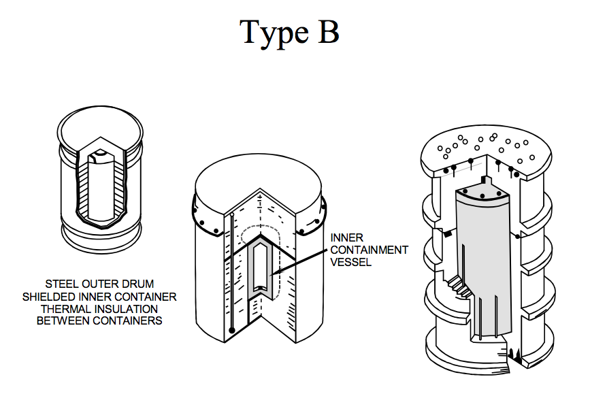

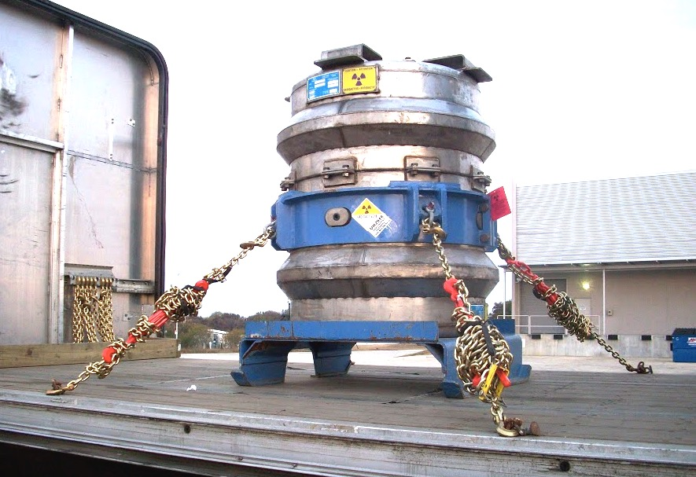

*Type B package secured to transport trailer. Photo courtesy of Jade Transportation*

**EMERGENCY RESPONSE**

***Federal Roles and Responsibility***

*DOE/NNSA*

DOE provides technical expertise and authority to implement the appropriate response to a nuclear or radiological emergency. Because radiological or nuclear incidents could range widely in their implications (from lost or stolen materials to threat of terrorism and more), the emergency response assets available to DOE are vast.

The Radiological Assistance Program (RAP) contributes to the first response on a Federal level with teams that can respond within four to six hours of an event. In addition to advising on public safety and conducting recovery operations for lost or stolen materials, the RAP team can aid in the assessment, monitoring, contamination control, and decontamination of the radiation environment.

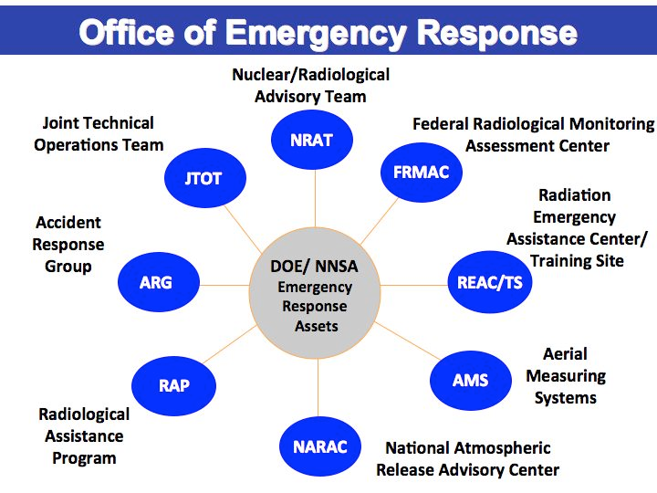

Another DOE asset is the Nuclear/Radiological Advisory Team (NRAT). NRAT is capable of both domestic and international response and provides both highly specialized scientific and technical advice as well as operational support.

Helping to prevent an unnecessary full-scale response, Radiological Triage provides 24- hour-a-day, seven-days-a-week virtual assistance to first responders. Radiological Triage is an on-call team that supplies nuclear analysis and assessment to determine the threat level of a nuclear or radiological event, thereby providing support for Federal, State, and Local responders.

Another DOE response asset is Aerial Measuring Systems (AMS). AMS utilizes aviation-based equipment to conduct aerial radiation surveys, providing highly detailed spectral mapping and data telemetry. They also provide source searches in cases of stolen radioactive materials.

The Radiation Emergency Assistance Center/Training Site (REAC/TS) is also available during the response to a radiological emergency. REAC/TS provides expertise on health-related problems associated with radiological events. In addition to deploying three-person medical teams to respond to radiological incidents (available 24/7), REAC/TS trains health professionals, evaluates radiological dosage exposure, and maintains a Radiation Accident Registry System.

DOE’s National Atmospheric Release Advisory Center (NARAC) supplies plume models, or predictions of atmospheric transport of radioactivity from a nuclear accident or incident. Based at the Lawrence Livermore National Laboratories in California, NARAC identifies the affected areas of airborne or ground contamination as well as radiation dosage on a 24-hour basis. In addition, NARAC models supply maps with terrain and population, accounting for observed and forecasted weather.

A final DOE asset in responding to a radiological emergency is the Federal Radiological Monitoring and Assessment Center (FRMAC). FRMAC provides on-scene management of the consequences of a radiological event by providing multi-agency operational coordination, monitoring, and assessment. In addition, FRMAC has on-call reach-back capability for radiation protection and health physics advice within one hour of notification. FRMAC capabilities are both on the ground through field monitoring, data sampling and analysis, as well as digital data collection and telemetry.

*Source: United States Department of Energy*

*FBI*

The Attorney General (AG)/FBI Director leads the operational law enforcement response to, and criminal investigation of, terrorist threats/incidents within the US, its territories or territorial waters, as well as related intelligence collection activities within the United States.

The Federal government evaluates Chemical, Biological, Radiological, Nuclear, or Explosive (CBRNE) threats through a Threat Credibility Evaluation (TCE). The TCE evaluates whether the threat is imminent, credible and capable of causing substantial loss of life or damage to property, which are all necessary for the triggering of the Counterterrorism National Policy. All WMD threat information having a potential impact on the United States will be immediately passed to the FBI to conduct a timely TCE to: 1) Assess the credibility of the WMD threat, 2) Determine the likelihood that the threat will result in substantial loss of life or substantial damage to property, and 3) When necessary, consider initiation of the appropriate WMD search or response protocols.  Depending on the situation, State and Local representatives may be invited to participate in the TCE.

The FBI’s JTTF combines Federal, State, and Local law enforcement resources in a terrorist event. JTTFs aim to enhance cooperation between the different law enforcement agencies.

The FBI-led WMD Strategic Group (WMDSG) is an interagency crisis action team consisting of subject matter experts from 16 Federal departments and agencies.  The WMDSG coordinates and shares information during an incident and is located in the Strategic Information and Operations Center (SIOC) at FBI Headquarters.  SIOC also maintains communications with the Department of Homeland Security (DHS) and the White House.

The FBI’s Joint Operations Center (JOC) functions as an interagency command and control center for managing multi-agency preparation for, and the law enforcement and investigative response to, a credible terrorist threat or incident.  The JOC consists of four main groups: the Command Group, the Operations Group, the Operations Support Group and the Consequence Management Group. Depending on the situational circumstances, State department/agency personnel may be requested to staff any or all of the JOC groups.

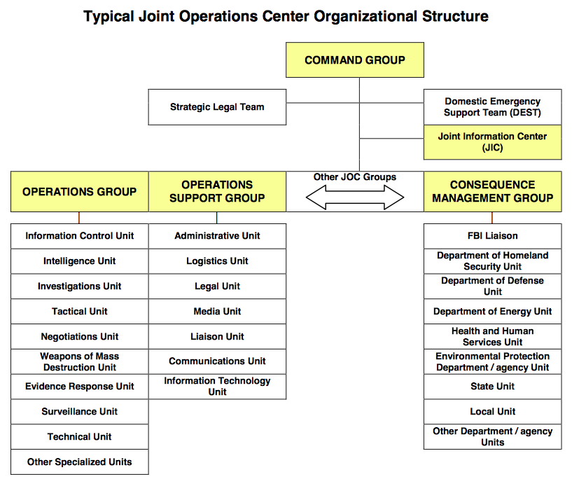

Another asset that can be utilized by the FBI during a terrorism incident is the Domestic Emergency Support Team (DEST). The DEST is a rapidly deployable interagency emergency support team to assist the FBI during domestic terrorist events involving the use of CBRNE weapons. The DEST is incorporated directly into the existing on-site FBI crisis management structure to advise the On-Scene Commander (OSC) of Federal-level capabilities that can be brought to bear on the incident. Besides providing interagency crisis management assistance, the DEST can provide information management support and enhanced communications to ensure the OSC maintains connectivity with national-level decision makers during the on-going crisis. The DEST can be organized to provide the expert advice required for certain explosive devices and their components including CBRNE dispersal devices. Technical expertise and equipment is also available to conduct on-site activities like threat sampling, technical measurements, tactical intelligence collection, evidence collection, and other actions.

*Source: Federal Bureau of Investigation*

Local emergency personnel are typically the first responders in the event of an incident or accident. Their ability to act is extremely important. In the event of a radiological release, they are the first to extinguish any fires or organize evacuations.

**APPENDIX A**

**TERMS AND DEFINITIONS**

**Accident -** An unexpected or unintentional occurrence, including acts of God, involving a radioactive material shipment that does not involve suspected criminal or terrorist activity.

**Air sampling** - The collection of samples of air to measure the radioactivity or to detect the presence of radioactive material, particulate matter, or chemical pollutants in the air.

**ALARA** - Acronym for “As Low As Reasonably Achievable,” means making every reasonable effort to maintain exposures to ionizing radiation as far below the dose limits as practical, consistent with the purpose for which the licensed activity is undertaken, taking into account the State of technology, the economics of improvements in relation to State of technology, the economics of improvements in relation to benefits to the public health and safety, and other societal and socioeconomic considerations, and in relation to utilization of nuclear energy and licensed materials in the public interest (see 10 CFR 20.1003).

**Background radiation** - Radiation from cosmic sources; naturally occurring radioactive materials, including radon (except as a decay product of source or special nuclear material) and global fallout as it exists in the environment from the testing of nuclear explosive devices. It does not include radiation from source, byproduct, or special nuclear materials regulated by the Nuclear Regulatory Commission.

**Becquerel (Bq)** - The unit of radioactive decay equal to1 disintegration per second. 37 billion (3.7x1010) becquerels = 1 curie (Ci).

**Bioassay** - The determination of kinds, quantities, or concentrations, and in some cases, the locations, of radioactive material in the human body, whether by direct measurement (in vivo counting) or by analysis and evaluation of materials excreted or removed (in vitro) from the human body.

**Calibration** - The adjustment, as necessary, of a measuring device such that it responds within the required range and accuracy to known values of input.

**Contamination** - Undesired radioactive material that is deposited on the surface of or inside structures, areas, objects, or people.

**Criticality** - A term used in reactor physics to describe the state when the number of neutrons released by fission is exactly balanced by the neutrons being absorbed (by the fuel and poisons) and escaping the reactor core. A reactor is said to be “critical” when it achieves a self-sustaining nuclear chain reaction, as when the reactor is operating.

**Curie (Ci)** - The basic unit used to describe the intensity of radioactivity in a sample of material. The curie is equal to 37 billion (3.7X1010) disintegrations per second, which is approximately the activity of 1 gram of radium. A curie is also a quantity of any radionuclide that decays at a rate of 37 billion disintegrations per second. It is named for Marie and Pierre Curie, who discovered radium in 1898.

**Decommissioning** - The process of closing a facility followed by reducing residual radioactivity to a level that permits the release of the property for unrestricted use (see 10 CFR 20.1003).

**Decontamination** - The reduction or removal of contaminating radioactive material from a structure, area, object, or person. Decontamination may be accomplished by: (1) treating the surface to remove or decrease the contamination, (2) letting the material stand so that the radioactivity is decreased because of natural radioactive decay, or (3) covering the contamination to shield or attenuate the radiation emitted (see 10 CFR 20.1003 and §20.1402).

**Detector** - A material or device that is sensitive to radiation and can produce a response signal suitable for measurement or analysis. A radiation detection instrument.

**Dose** - The absorbed dose, given in rads (or the international system of units, grays), that represents the energy absorbed from the radiation in a gram of any material. Furthermore, the biological dose or dose equivalent, given in rem or sieverts, is a measure of the biological damage to living tissue from the radiation exposure.

**Dose equivalent** - The product of absorbed dose in tissue multiplied by a quality factor, and then sometimes multiplied by other necessary modifying factors at the location of interest. It is expressed numerically in rems or sieverts (see 10 CFR 20.1003).

**Dose rate** - The ionizing radiation dose delivered per unit time. For example, rem or sieverts per hour.

**Dose, absorbed** - The amount of energy deposited in any substance by ionizing radiation per unit mass of the substance. It is expressed numerically in rads or grays.

**Dosimeter** - A small portable instrument (such as a film badge, thermoluminescent or pocket dosimeter) for measuring and recording the total accumulated personnel dose of ionizing radiation.

**Dosimetry** - The theory and application of the principles and techniques involved in the measurement and recording of ionizing radiation doses.

**Excepted packaging** - is used to transport material with extremely low levels of radioactivity. Excepted packaging is authorized for limited quantities of radioactive material that would pose a very low hazard if released in an accident. Examples of material typically shipped in excepted packaging include consumer goods such as smoke detectors. These packagings are excepted (excluded) from specific packaging, labeling, and shipping paper requirements; they are, however, required to have the letters “UN” and the appropriate four-digit UN identification number marked on the outside of the package. Requirements for excepted packaging are addressed in 49 CFR 173.421.

**Exposure** - Being exposed to ionizing radiation or to radioactive material.

**Fissile material** - The radionuclides uranium-233, uranium-235, plutonium-239, and plutonium-241, or any combination of these radionuclides. Fissile material means the fissile nuclides themselves, not material containing fissile nuclides. Unirradiated natural uranium and depleted uranium and natural uranium or depleted uranium, that have been irradiated in thermal reactors only, are not included in this definition. Certain exclusions from fissile material controls are provided in 10 CFR 71.15.

**Geiger-Mueller counter** - A radiation detection and measuring instrument. It consists of a gas-filled tube containing electrodes, between which there is an electrical voltage, but no current flowing. When ionizing radiation passes through the tube, a short, intense pulse of current passes from the negative electrode to the positive electrode and is measured or counted. The number of pulses per second measures the intensity of the radiation field. It was named for Hans Geiger and W. Mueller, who invented it in the 1920s. It is sometimes called simply a Geiger counter or a GM counter and is the most commonly used portable radiation instrument.

**Gray (Gy)** - is the SI unit of absorbed dose (Rad). One gray is equal to an absorbed dose of 1 Joule/kilogram (100 rads)

**Half-life** - The time in which one half of the atoms of a particular radioactive substance disintegrates into another nuclear form. Measured half-lives vary from millionths of a second to billions of years. Also called physical or radiological half-life.

**High-level waste** - Radioactive materials at the end of a useful life cycle that should be properly disposed of, including:

1. The highly radioactive material resulting from the reprocessing of spent nuclear fuel, including liquid waste directly in reprocessing and any solid material derived from such liquid waste that contains fission products in concentrations.

2. Irradiated reactor fuel; and

3. Other highly radioactive material that the NRC, consistent with existing law, determines by rule requires permanent isolation.

**Incident -** An intentional act attempting damage, theft, unauthorized use or loss of control of a radioactive materials shipment involving suspected criminal or terrorist activity.

I**ndustrial package** - Used in certain shipments of low activity material and contaminated objects, which are usually categorized as radioactive waste. Most low level waste is shipped for disposal in industrial packaging. Department of Transportation (DOT) regulations require that industrial packages allow no identifiable release of the material to the environment during normal transportation and handling. There are three categories of industrial packages: IP-1, IP-2, and IP- 3. The category of package will be marked on the exterior of the package. Requirements for industrial packaging are addressed in 49 CFR 173.411.

**Isotope** - each of two or more forms of the same element that contain equal numbers of protons but different numbers of neutrons in their nuclei, and hence differ in relative atomic mass but not in chemical properties; in particular, a radioactive form of an element. For example, there are 3 isotopes of the element hydrogen; one of the three isotopes (tritium) is radioactive.

**Low-level waste** - A general term for a wide range of wastes having low levels of radioactivity. Industries, hospitals and medical, educational, or research institutions; private or government laboratories; and nuclear fuel cycle facilities (e.g., nuclear power reactors and fuel fabrication plants) that use radioactive materials generate low-level wastes as part of their normal operations. These wastes are generated in many physical and chemical forms and levels of contamination (see 10 CFR 61.2). Low-level radioactive wastes containing source, special nuclear, or byproduct material are acceptable for disposal in a land disposal facility. For the purposes of this definition, low-level waste has the same meaning as in the Low-level Waste Policy Act, that is, radioactive waste not classified as high-level radioactive waste, transuranic waste, spent nuclear fuel, or byproduct material as defined in section 11e.(2) of the Atomic Energy Act (uranium or thorium tailings and waste).

**Low Specific Activity (LSA) Material** – means radioactive material with limited specific activity which is nonfissile or is excepted under 10 CFR §71.15. Shielding materials surrounding the LSA material may not be considered in determining the estimated average specific activity of the package contents. LSA material is categorized into 3 groups based on material content and activity level.

**Plume Model** - a computer model that simulates atmospheric transport of radioactivity from a nuclear accident or incident, identifying areas of airborne or ground contamination

**Rad** - The special unit for radiation absorbed dose, which is the amount of energy from any type of ionizing radiation (e.g., alpha, beta, gamma, neutrons, etc.) deposited in any medium (e.g., water, tissue, air). A dose of one rad means the absorption of 100 ergs (a small but measurable amount of energy) per gram of absorbing tissue (100 rad = 1 gray).

**Radiation (ionizing radiation)** - Alpha particles, beta particles, gamma rays, x-rays, neutrons, high-speed electrons, high-speed protons, and other particles capable of producing ions. Radiation, as used in 10 CFR Part 20, does not include non-ionizing radiation, such as radio- or microwaves, or visible, infrared, or ultraviolet light (see also 10 CFR 20.1003).

**Radiation area** - Any area with radiation levels greater than 5 millirems (0.05 millisievert) in one hour at 30 centimeters from the source or from any surface through which the radiation penetrates.

**Radiation detection instrument** - A device that detects and displays the characteristics of ionizing radiation.

**Radiation shielding** - Reduction of radiation by interposing a shield of absorbing material between any radioactive source and a person, work area, or radiation-sensitive device.

**Radiation source** - Usually a sealed source of radiation used in teletherapy and industrial radiography, as a power source for batteries (as in use in space craft), or in various types of industrial gauges. Machines, such as accelerators and radioisotope generators, and natural radionuclides may be considered sources.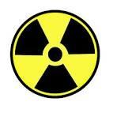

**Radiation warning symbol** - An officially prescribed symbol (a magenta or black trefoil) on a yellow background that must be displayed where certain quantities of radioactive materials are present or where certain doses of radiation could be received.

**Radioactive contamination** - Deposition of radioactive material in any place where it may harm persons or equipment.

**Radioactive decay** - Large unstable atoms can become more stable by emitting radiation. This process is called radioactive decay. This radiation can be emitted in the form of a positively charged ALPHA particle, a negatively charged BETA particle, or GAMMA RAYS or X-RAYS.

**Radioactivity** - The spontaneous emission of radiation, generally alpha or beta particles, often accompanied by gamma rays, from the nucleus of an unstable isotope. Also, the rate at which radioactive material emits radiation. Measured in units of becquerels or disintegrations per second.

**Radiography** - The making of a shadow image on photographic film by the action of ionizing radiation.

**Radiological survey** - The evaluation of the radiation hazards accompanying the production, use, or existence of radioactive materials under a specific set of conditions. Such evaluation customarily includes a physical survey of the disposition of materials and equipment, measurements or estimates of the levels of radiation that may be involved, and a sufficient knowledge of processes affecting these materials to predict hazards resulting from expected or possible changes in materials or equipment.

**Release** - uncontrolled release of radioactive material from its containment; this either threatens to, or does, cause exposure to a radioactive hazard; such an incident may occur accidentally or deliberately

**REM** - The acronym for Roentgen Equivalent Man is a standard unit that measures the effects of ionizing radiation on humans. The dose equivalent in rem is equal to the absorbed dose in rads multiplied by the quality factor of the type of radiation (see 10 CFR 20.1004).

**Sealed source** - Any radioactive material or byproduct encased in a capsule designed to prevent leakage or escape of the material.

**Shielding** - Any material or obstruction that absorbs radiation and thus tends to protect personnel or materials from the effects of ionizing radiation.

**Sievert (Sv)** - The new international system (SI) unit for dose equivalent. 1 sievert = 100 rem.

**Special nuclear material** - Plutonium, uranium-233, or uranium enriched in the isotopes uranium-233 or uranium-235.

**Stay time** - The period during which personnel may remain in a restricted area in a reactor before accumulating some permissible occupational dose.

**Survey meter** - Any portable radiation detection instrument especially adapted for inspecting an area or individual to establish the existence and amount of radioactive material present.

**Type A package** - Type A packaging is used to transport small quantities of radioactive material with higher concentrations of radioactivity than those shipped in industrial packaging. Type A packaging is typically constructed of steel, wood, or fiberboard, and has an inner containment vessel made of glass, plastic, or metal surrounded with packing material made of polyethylene, rubber, or vermiculite. Type A packaging and its radioactive contents must meet standard testing requirements. These requirements ensure that the package retains its containment integrity and shielding under normal transport conditions. Type A Package requirements are addressed in 49 CFR 173.412. Type A Packages are not, however, designed to withstand the forces of an accident.

**Type B package** - Type B packaging is used to transport material with the highest levels of radioactivity. Type B Packages must withstand all Type A Package tests, and an additional series of tests that simulate severe or “worst case” accident conditions. Accident conditions are simulated by performance testing and engineering analysis. Life endangering amounts of radioactive material are required to be transported in Type B Packages. Requirements for Type B Packages are addressed in 49 CFR 173.413 and 10 CFR 71. Type B packaging sizes range from that used for small radiography cameras to large, heavily shielded, steel Type B packages that weigh up to 125 tons.

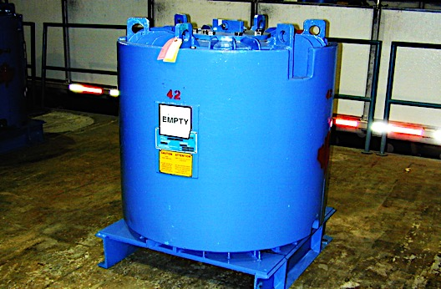

*Type B package. Photo courtesy of Secured Transportation Services, LLC*

**Very high radiation area** - An area accessible to individuals, in which radiation levels exceed 500 rad (5 gray) in one hour at 1 meter from the source or from any surface that the radiation penetrates (see 10 CFR 20.1003).

**Waste, radioactive** - Radioactive materials at the end of a useful life cycle or in a product that is no longer useful and should be properly disposed of.

**Wipe sample** - A sample made for the purpose of determining the presence of removable radioactive contamination on a surface. It is done by wiping, with slight pressure, a piece of soft filter paper over a representative type of surface area. It is also known as a “swipe or smear” sample.

**X-rays** - Penetrating electromagnetic radiation (photon) having a wavelength that is much shorter than that of visible light. These rays are usually produced by excitation of the electron field around certain nuclei. In nuclear reactions, it is customary to refer to photons originating in the nucleus as x-rays.

**APPENDIX B**

**ACRONYMS AND ABBREVIATIONS**

|  |  |
| --- | --- |
| A/O | Alert and oriented |
| ALARA | As low as reasonably achievable |
| AMS | Aerial Measuring Systems |
| Bq | Becquerel |
| CASTOR | Type B package for storage and transport of radioactive material |
| CBRNE | Chemical Biological Radiological Nuclear Explosive |
| CFR | Code of Federal Regulations |
| Ci | Curie |
| CPM | Counts per minute |
| DEST | Domestic Emergency Support Team |
| DOE | Department of Energy |
| DOT | Department of Transportation |
| EMS | Emergency Medical Service |
| EPA | Environmental Protection Agency |
| ERG | Emergency Response Guidebook |
| FBI | Federal Bureau of Investigation |
| FEMA | Federal Emergency Management Agency |
| FRMAC | Federal Radiological Monitoring and Assessment Center |
| GMS | Global Material Security |
| HazMat | Hazardous Materials |
| HLW | High level waste |
| IC | Incident Commander |
| ICS | Incident Command System |
| JTTF | Joint Terrorism Task Force |
| LLW | Low level waste |
| LSA | Low specific activity |
| MLLW | Mixed low-level waste |
| mR/hr | Millirem/hour |
| NARAC | National Atmospheric Release Advisory Center |
| NNSA | National Nuclear Security Administration |
| NNSS | Nevada National Security Site |
| NRAT | Nuclear/Radiological Advisory Team |
| NRC | Nuclear Regulatory Commission |
| NV RERP | Nevada Radiological Emergency Response Plan |
| OST | NNSA Office of Secure Transportation |
| PIO | Public Information Officer |
| PPE | Personal protective equipment |
| R | Roentgen |
| RAP | DOE Radiological Assistance Program |
| REM | Roentgen Equivalent Man |
| REAC/TS | Radiation Emergency Assistance Center/Training Site |
| RQ | Reportable Quantity |
| RSO | Radiation Safety Officer |
| RWMS | Radioactive Waste Management Site |
| SIOC | Strategic Information and Operations Center |
| SR | State Route |
| Sv | Sievert |
| TEPP | DOE Transportation Emergency Preparedness Program |
| TCE | Threat Credibility Evaluation |
| TRU | Transuranic |
| TTX | Tabletop Exercise |
| UC | Unified Command |